3D Printer Experiment Documentation

Reusing Tray Procedure

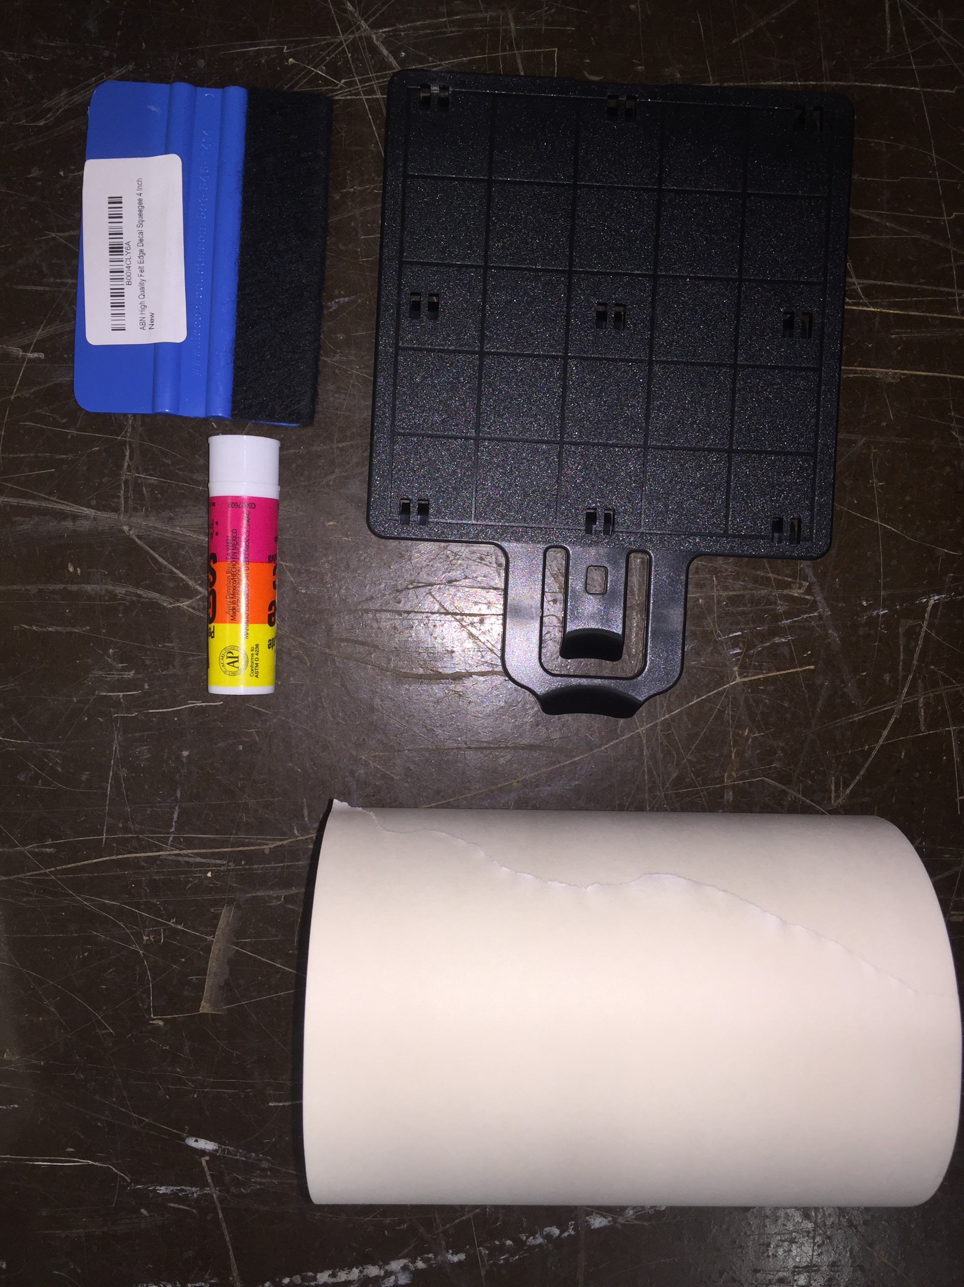
To reuse the Stratasys trays you will need a roll of transfer tape, plenty of gluesticks, and a squeegee. We’re following the procedure found here:
https://www.youtube.com/watch?v=S5EOMcNI2M4
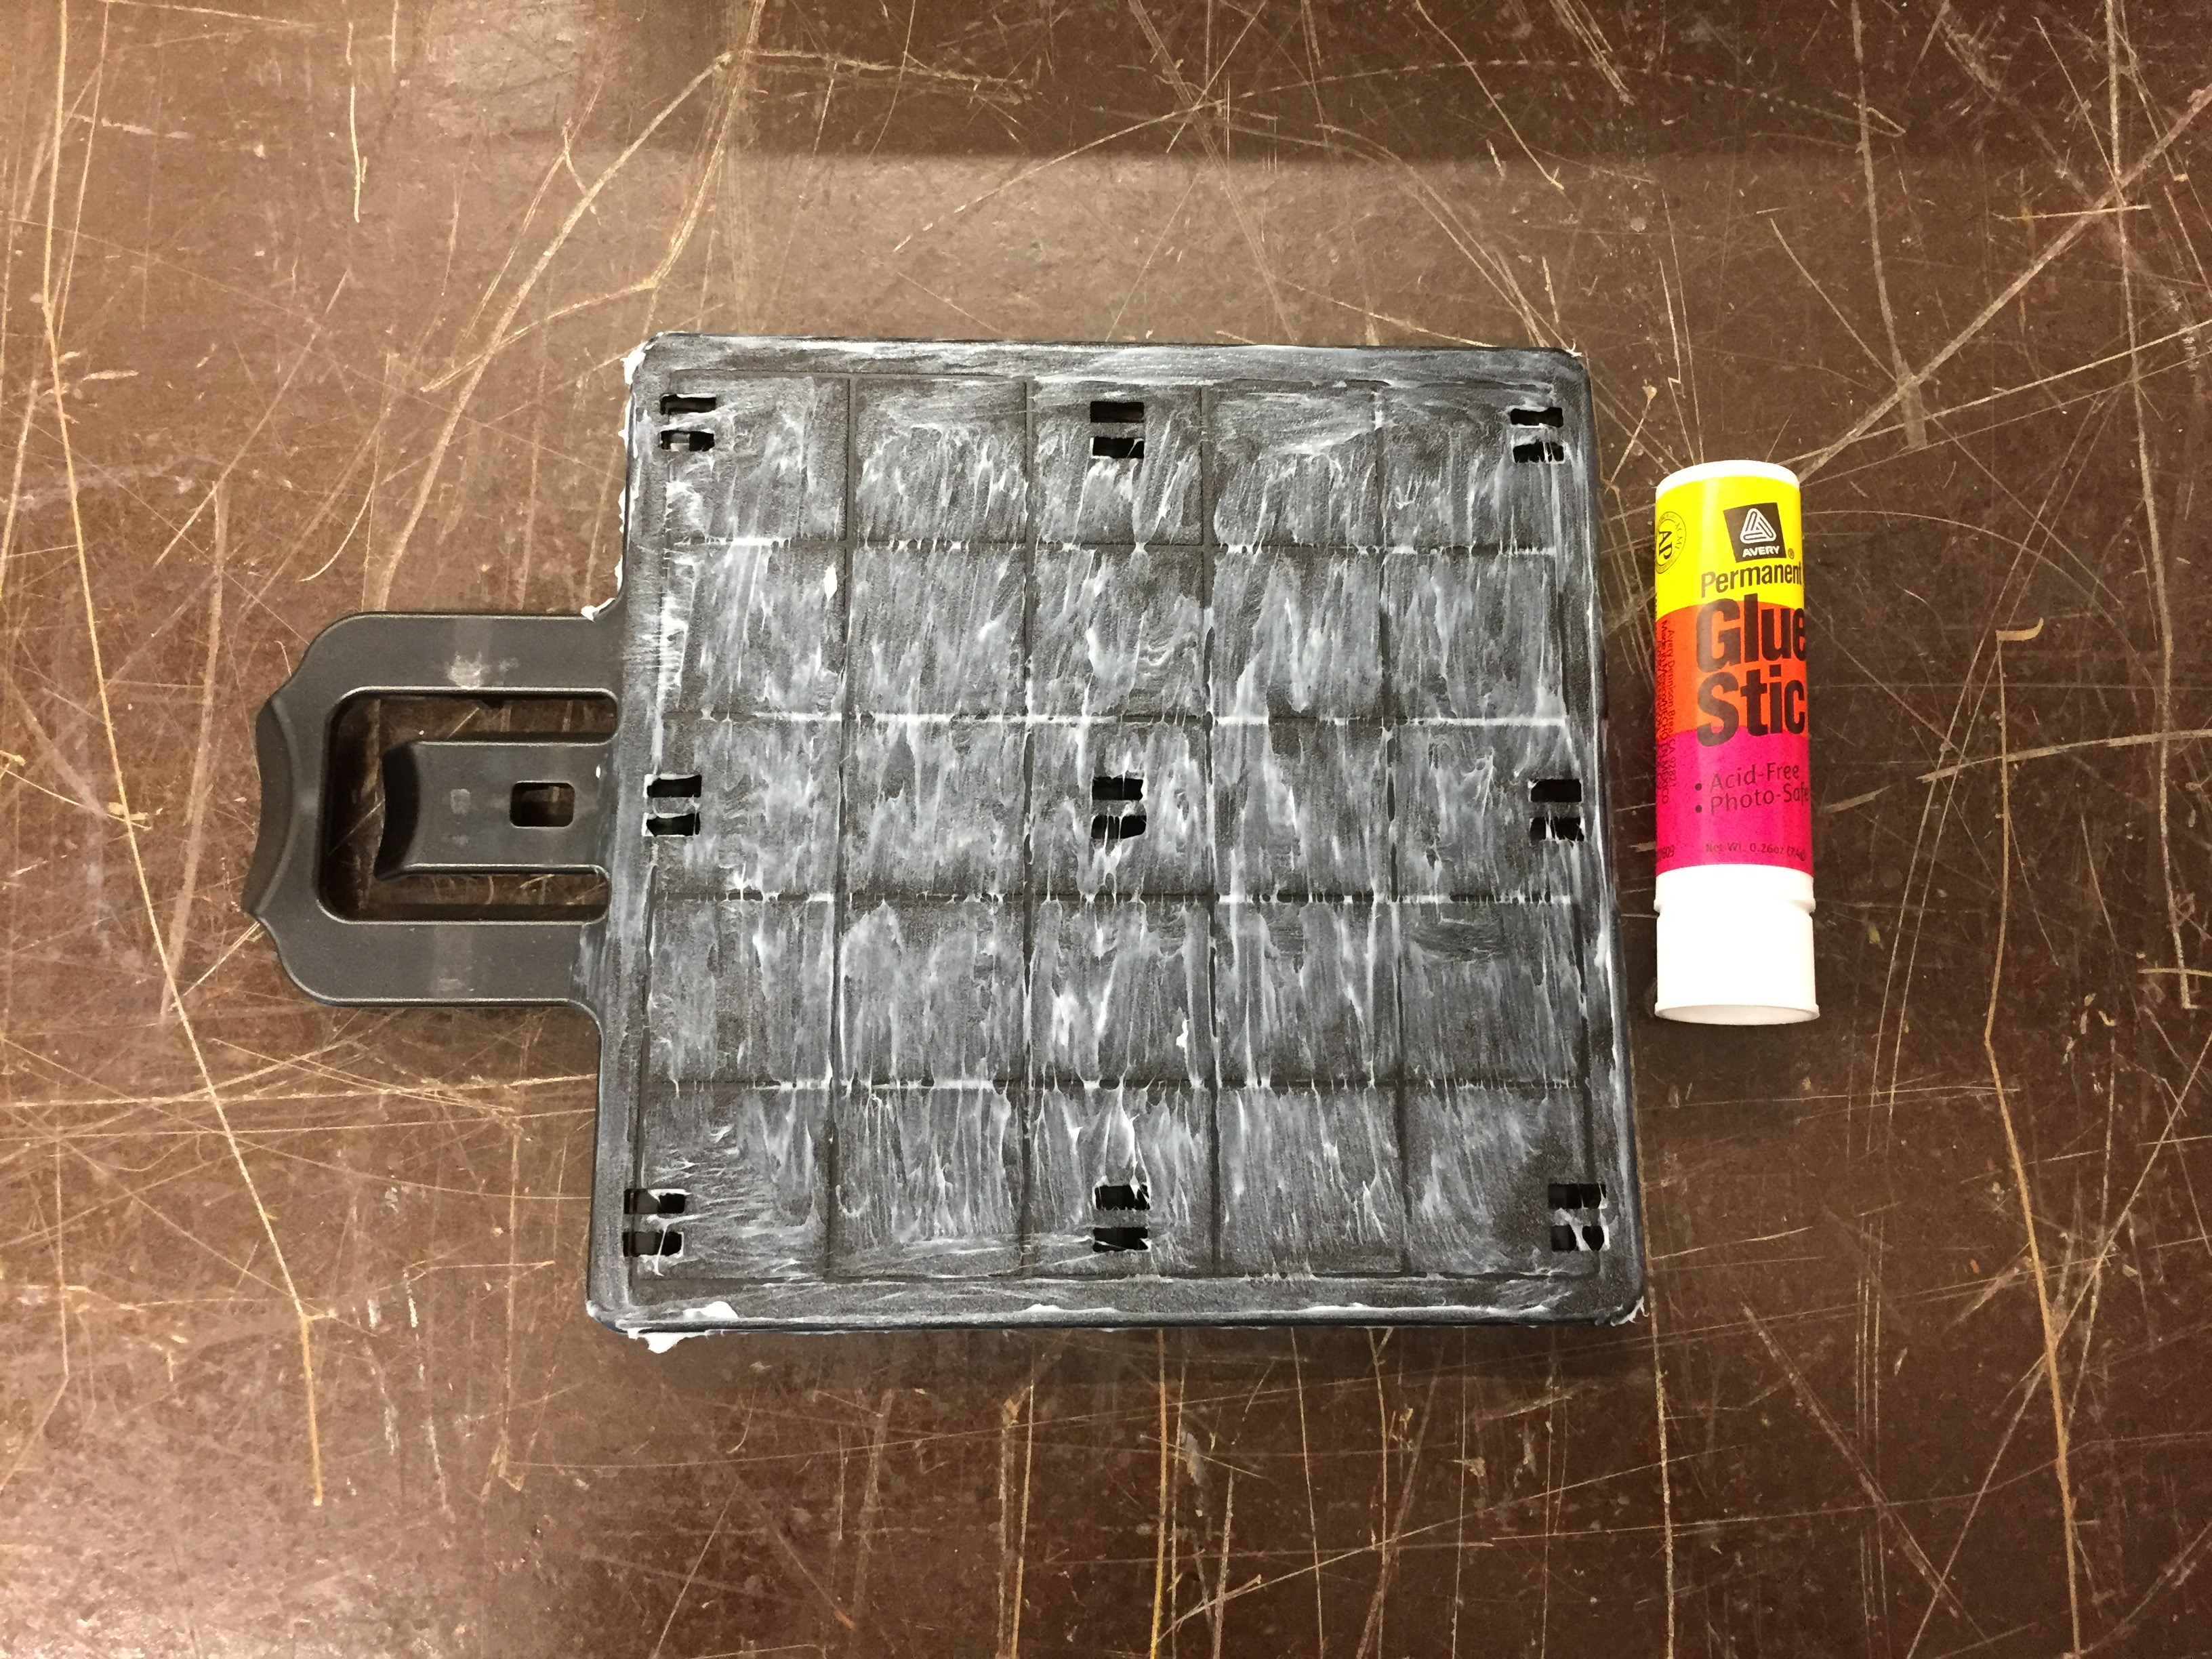
- Coat the surface of the tray with a large amount of the gluestick, performing multiple passes over the surface, to make sure the entire surface is covered. Also coat the side edges of the tray. This uses up approximately a quarter of a gluestick.
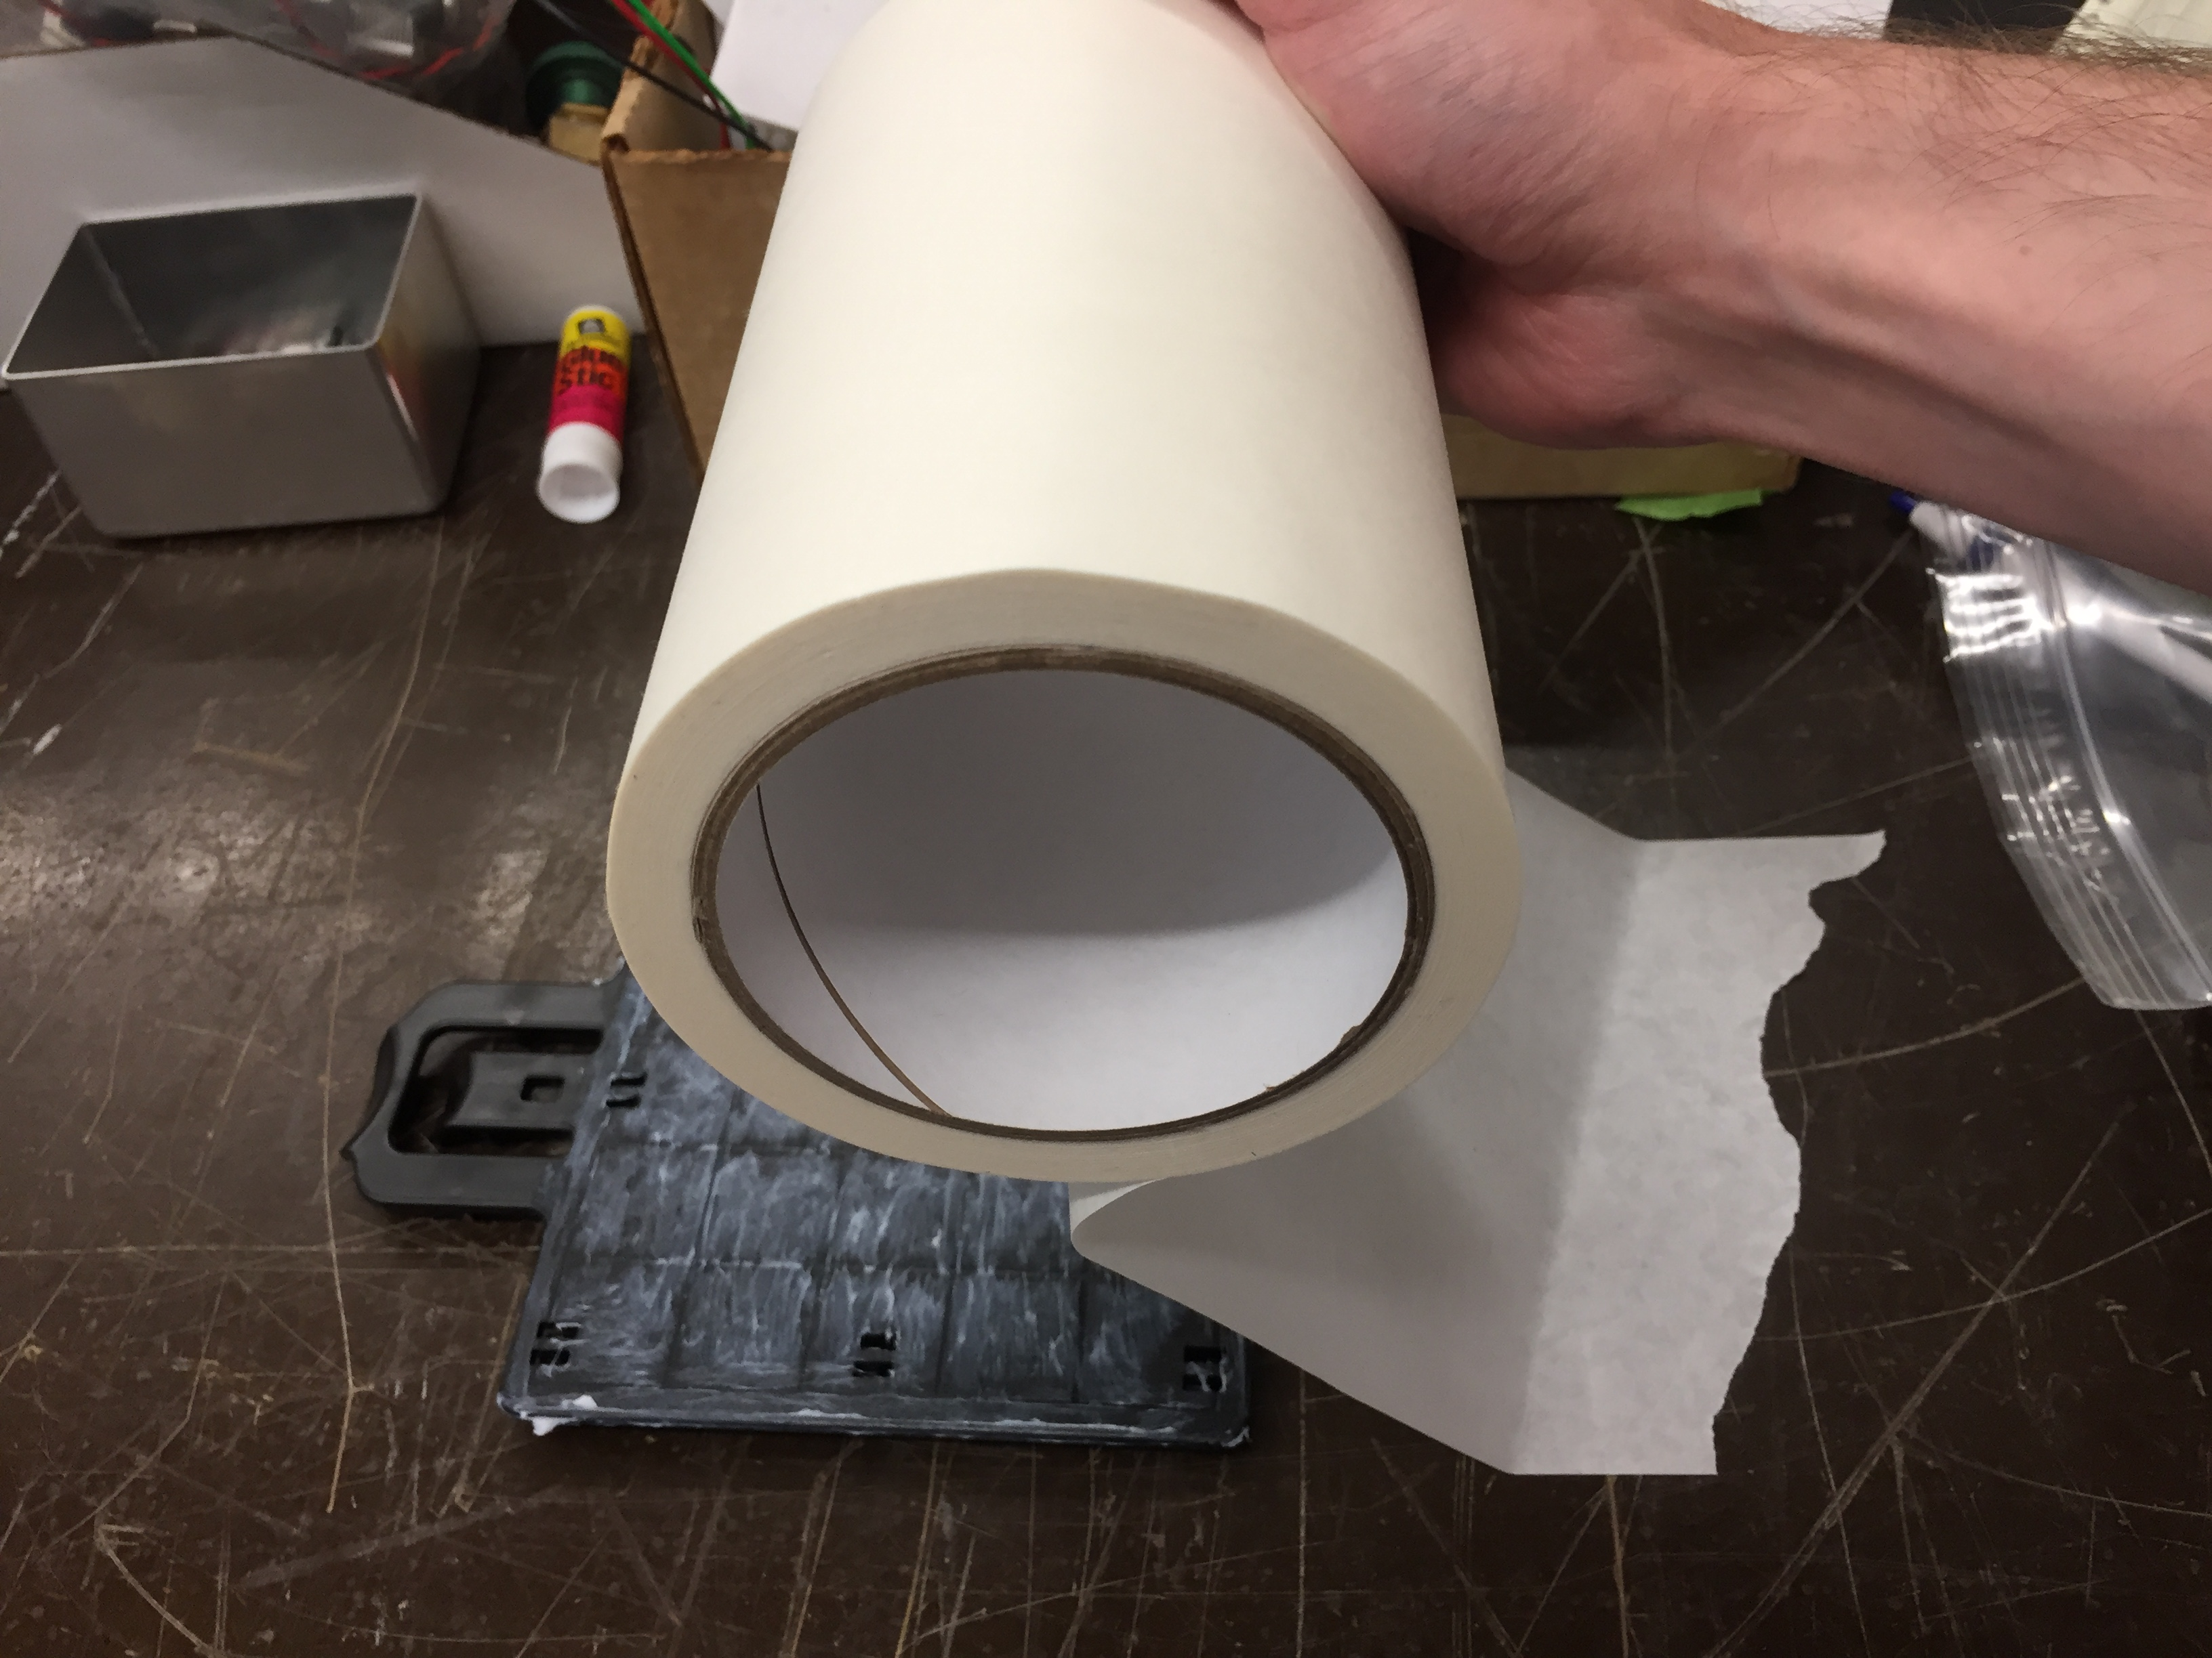
- We will cover the tray using a long strip of the tape. We start by anchoring the roll to the table to allow for a smooth pull over the surface of the tray.

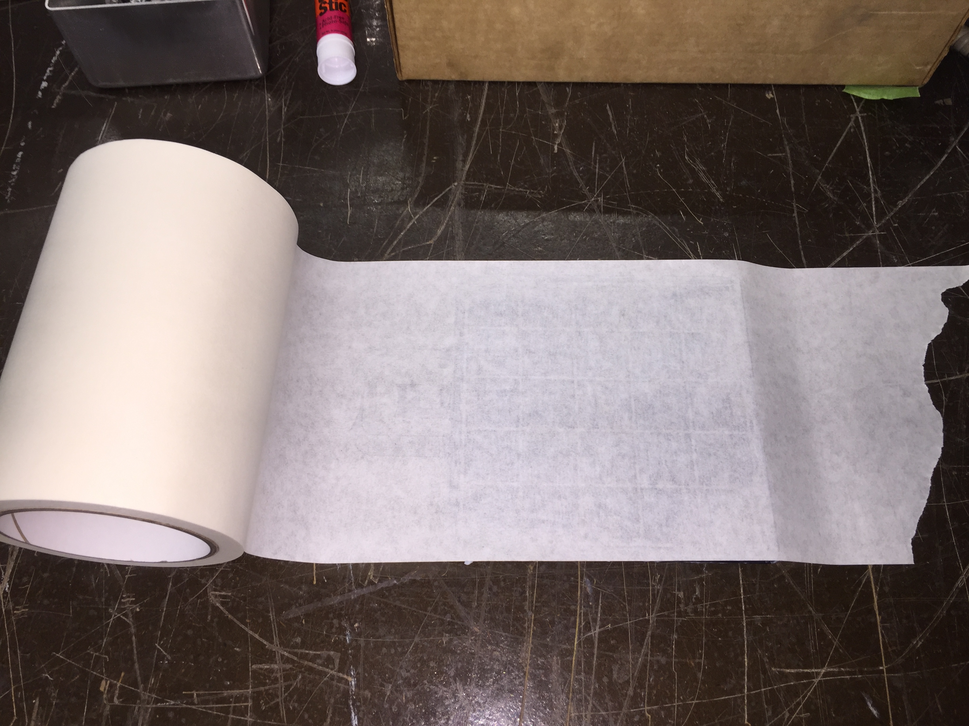
- Once the tape is anchored to the table as shown above, position the Stratasys tray underneath it so that it lines up with the direction of the tape. Smoothly unroll the tape and completely cover the tray.

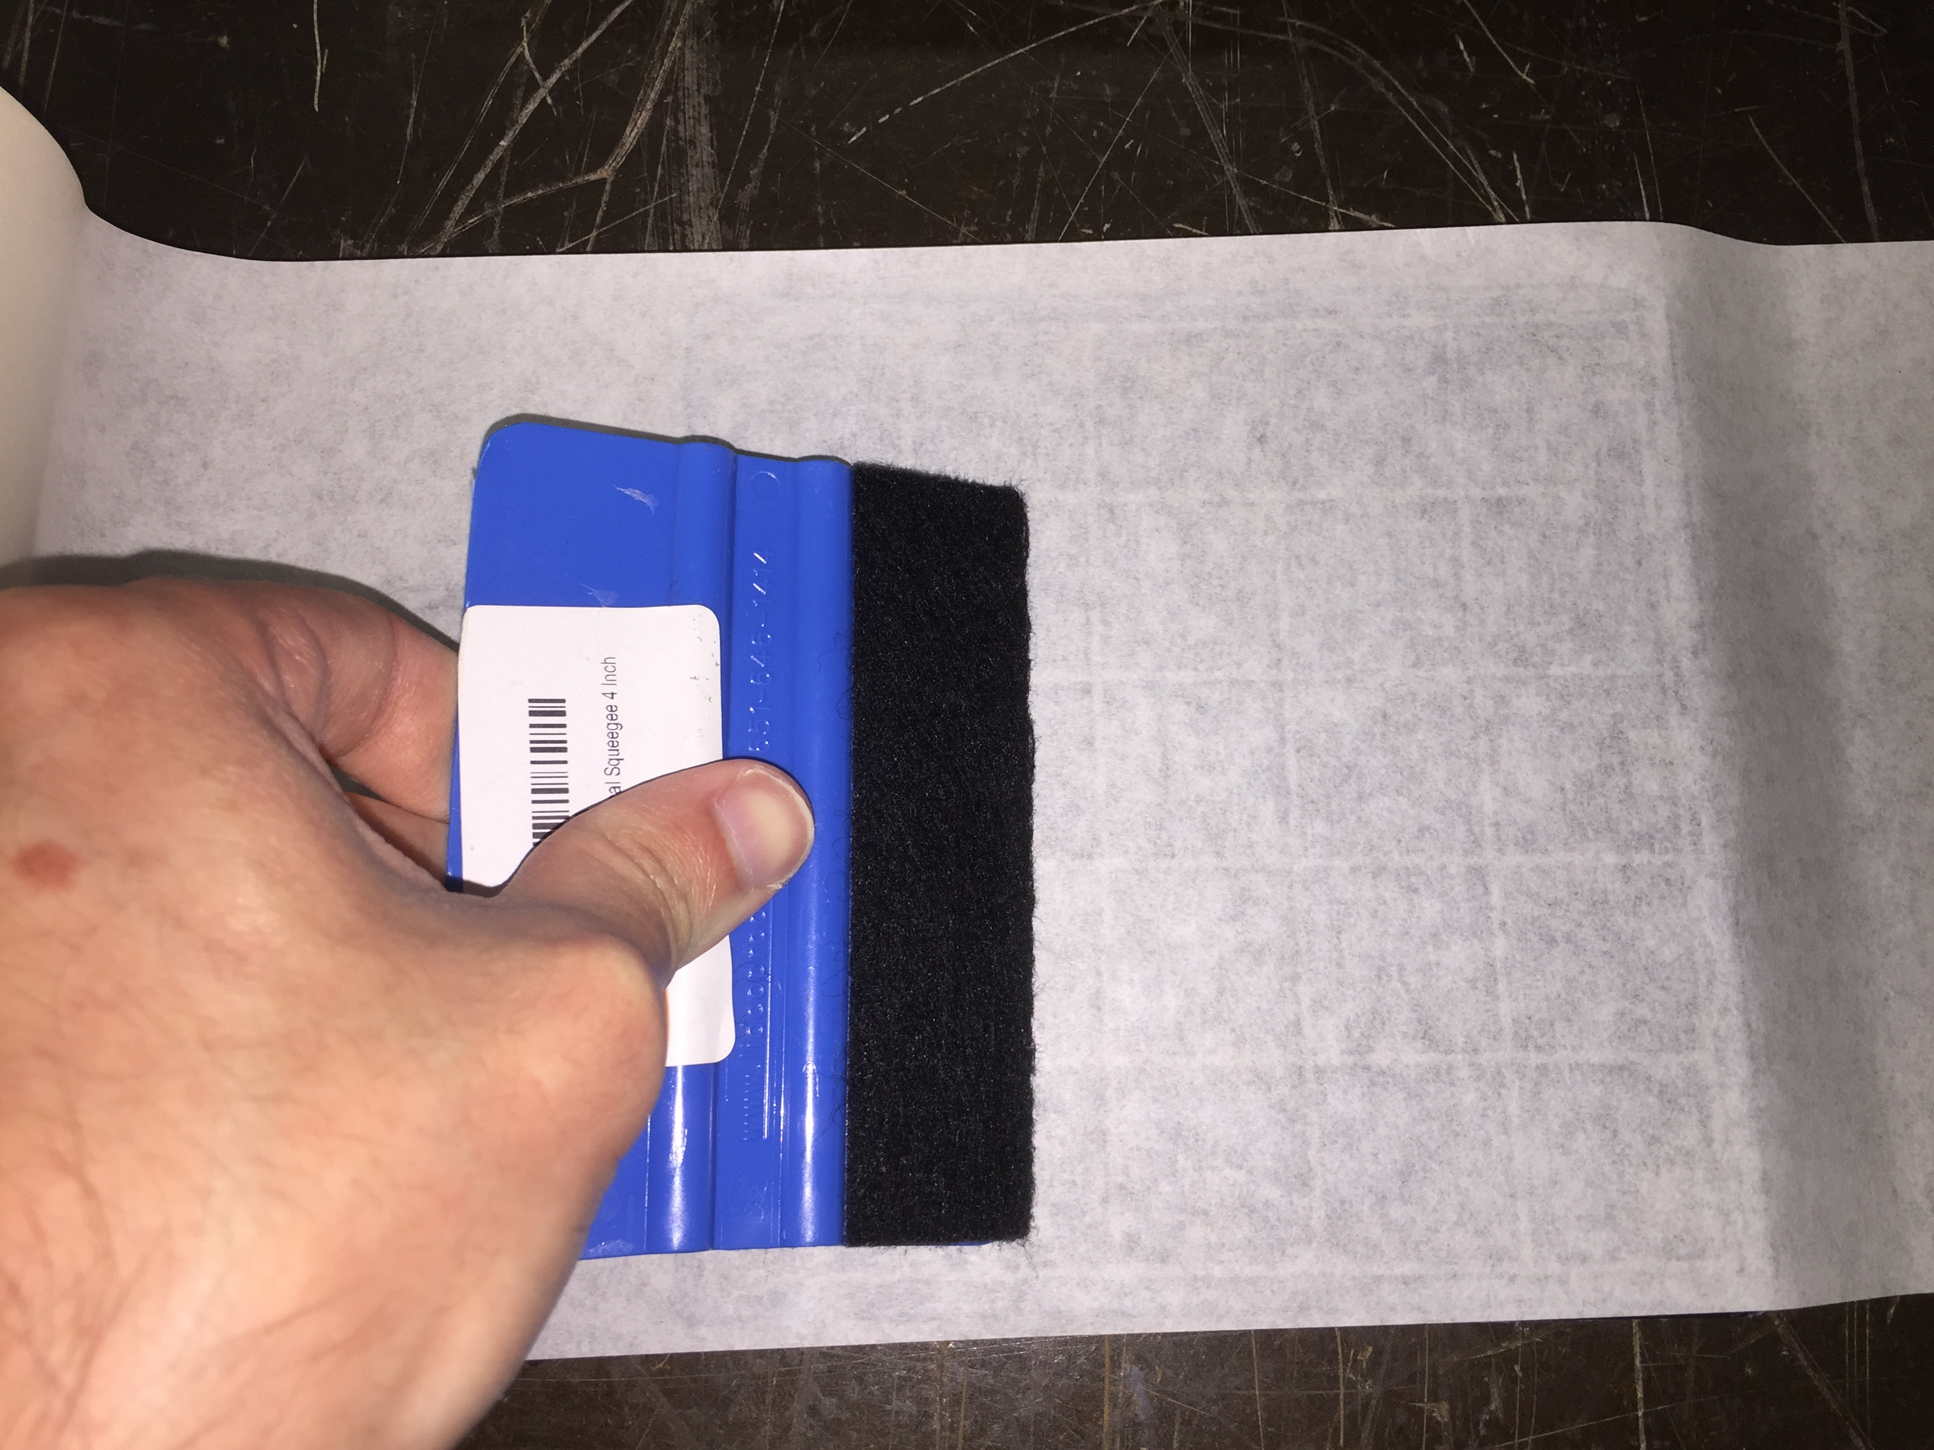
- Using the soft edge of the squeegee, push down on the tape and make sure it’s completely flat and even across the surface of the tray. Then use the opposite hard thin edge to push the tape into the grooves in the tray.
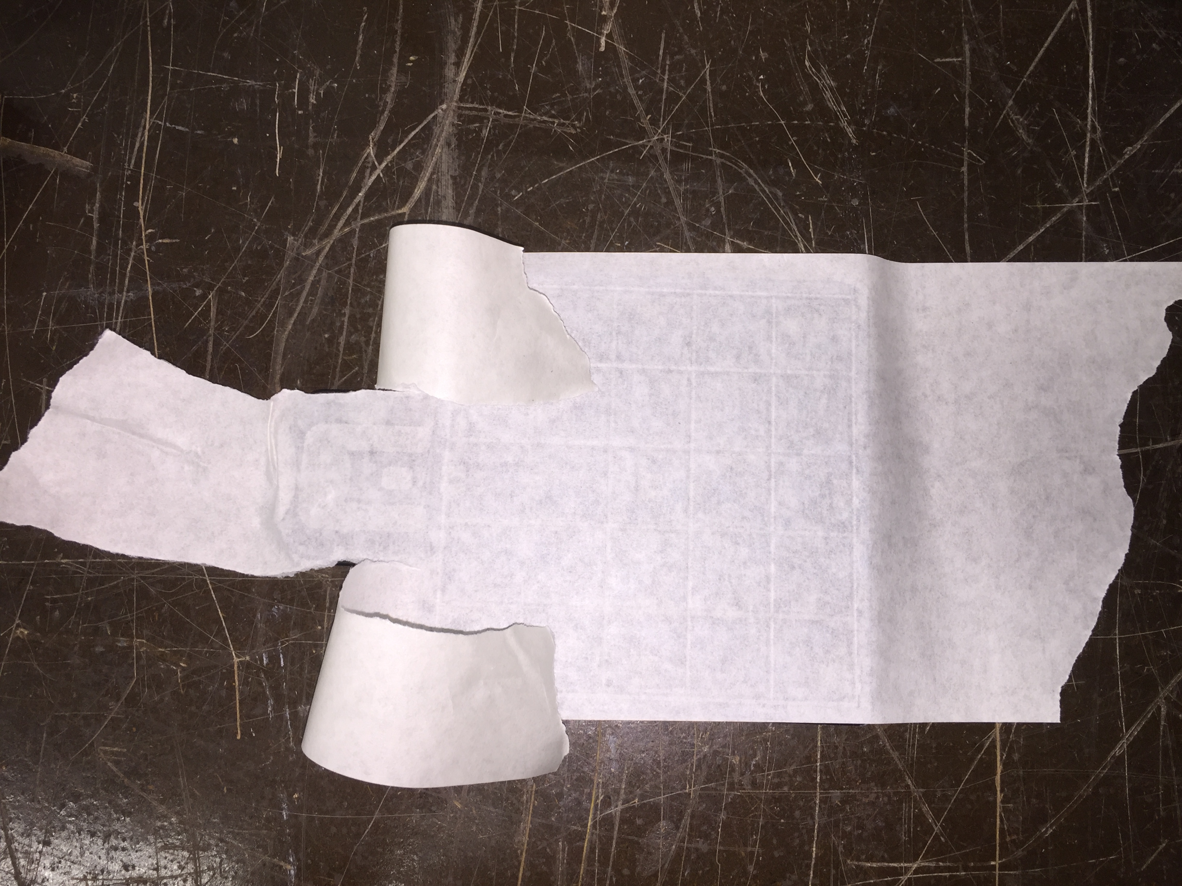
- Rip or cut the tape from the roll, making sure you still have some extra tape on the front to wrap around the handle. Rip the tape on both sides of the handle as shown at right to create 3 dangling strands.
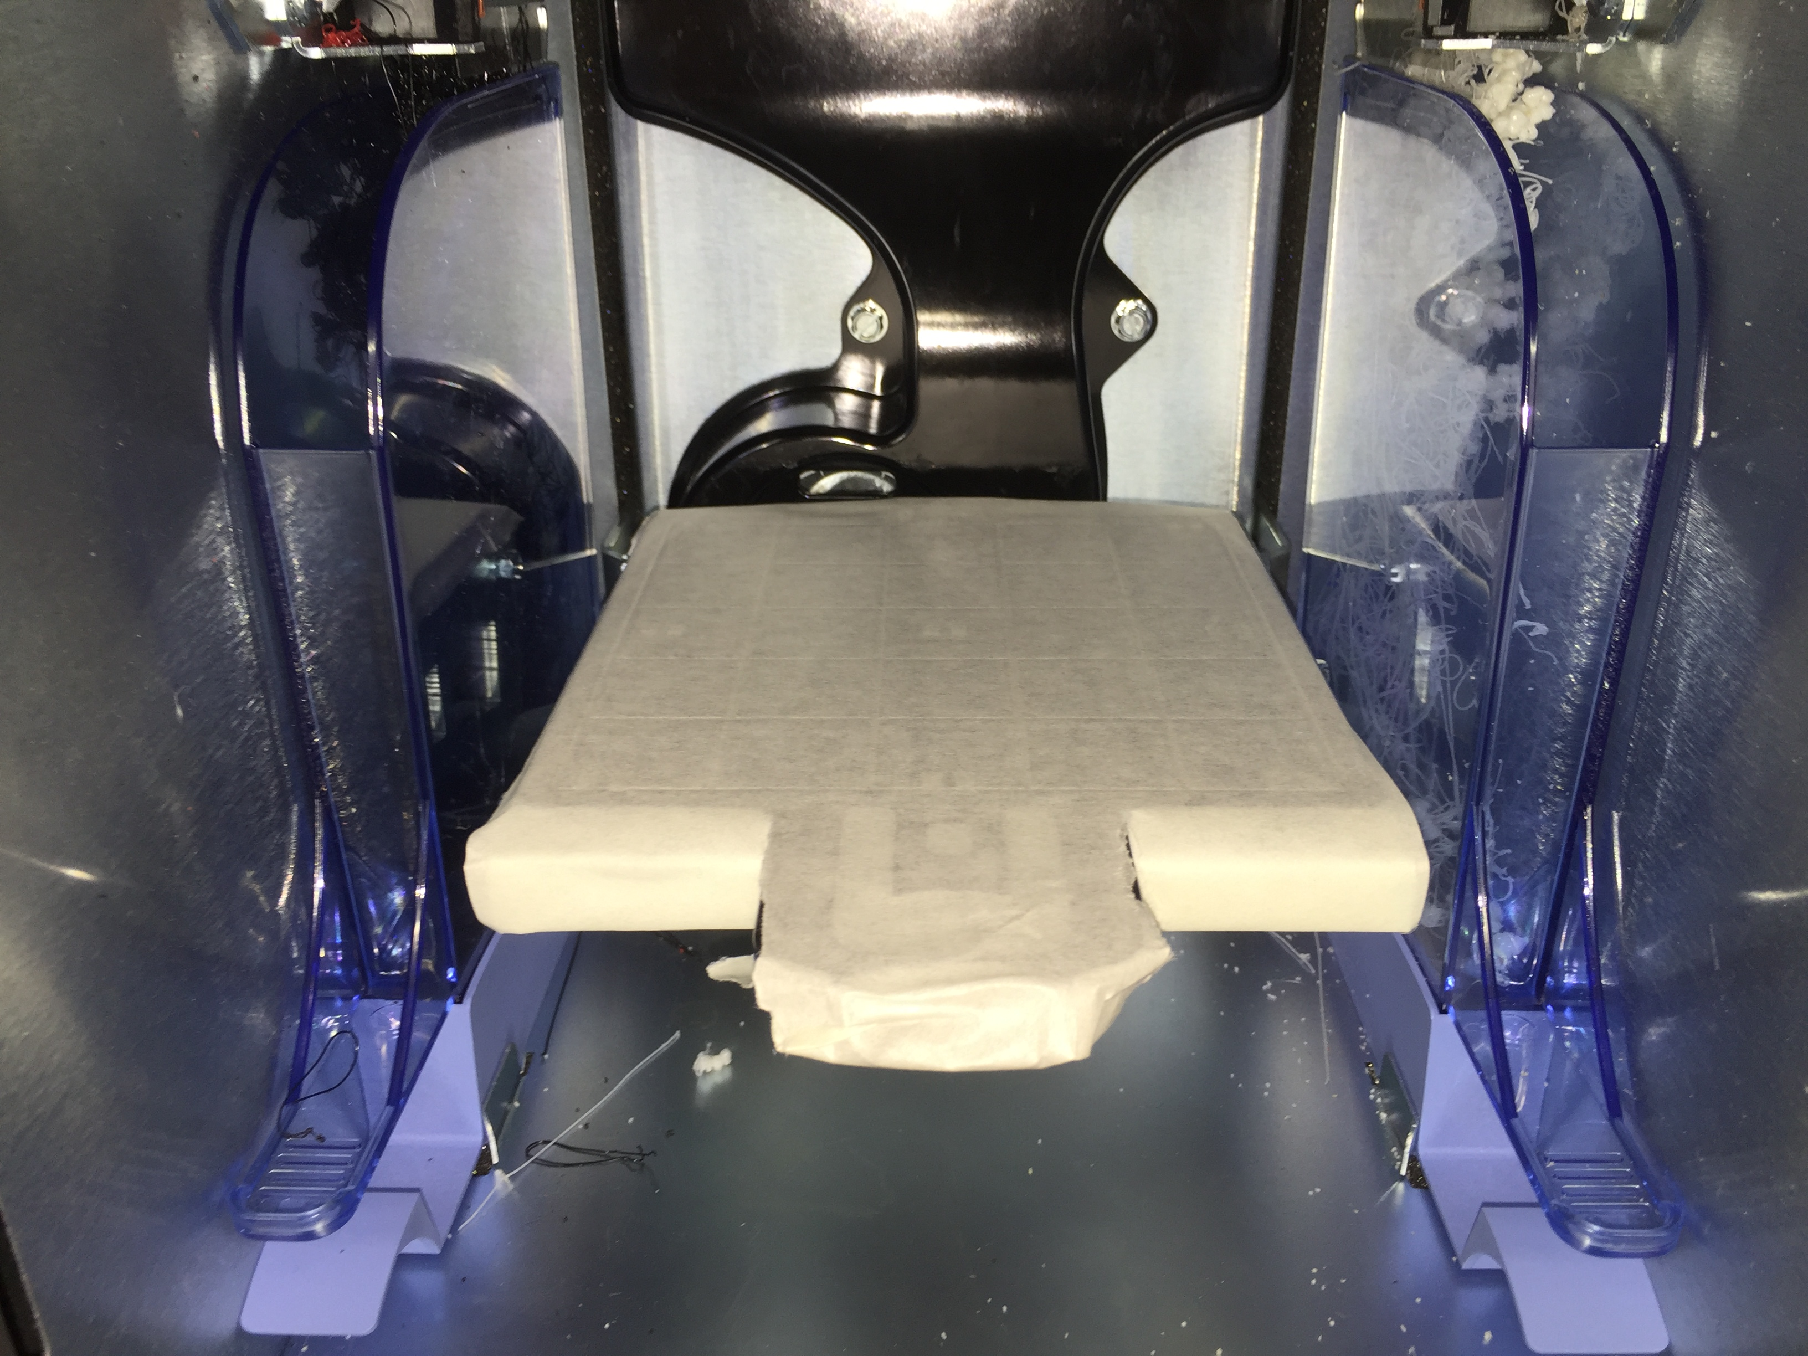
- Insert the tape-covered tray into the 3D printer and VERY CAREFULLY wrap the tape around the metal chassis the tray inserts into. Make sure the tape completely covers every edge and there are no dangling strands of tape that could catch on something in the printer and cause your print job to be destroyed. Of particular care should be the tape in the back which has to be completely wrapped around the back of the chassis and taped to the underside which requires you to push the tape past the fan in the back of the printer.

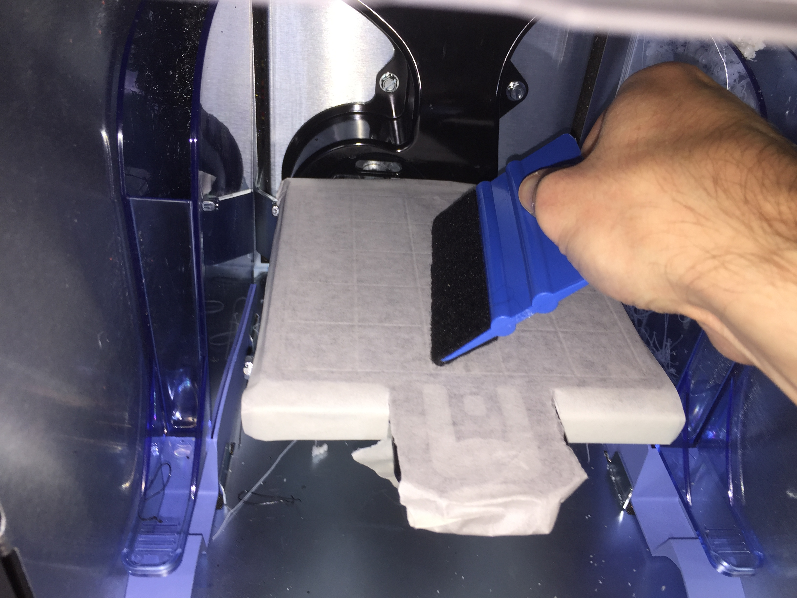
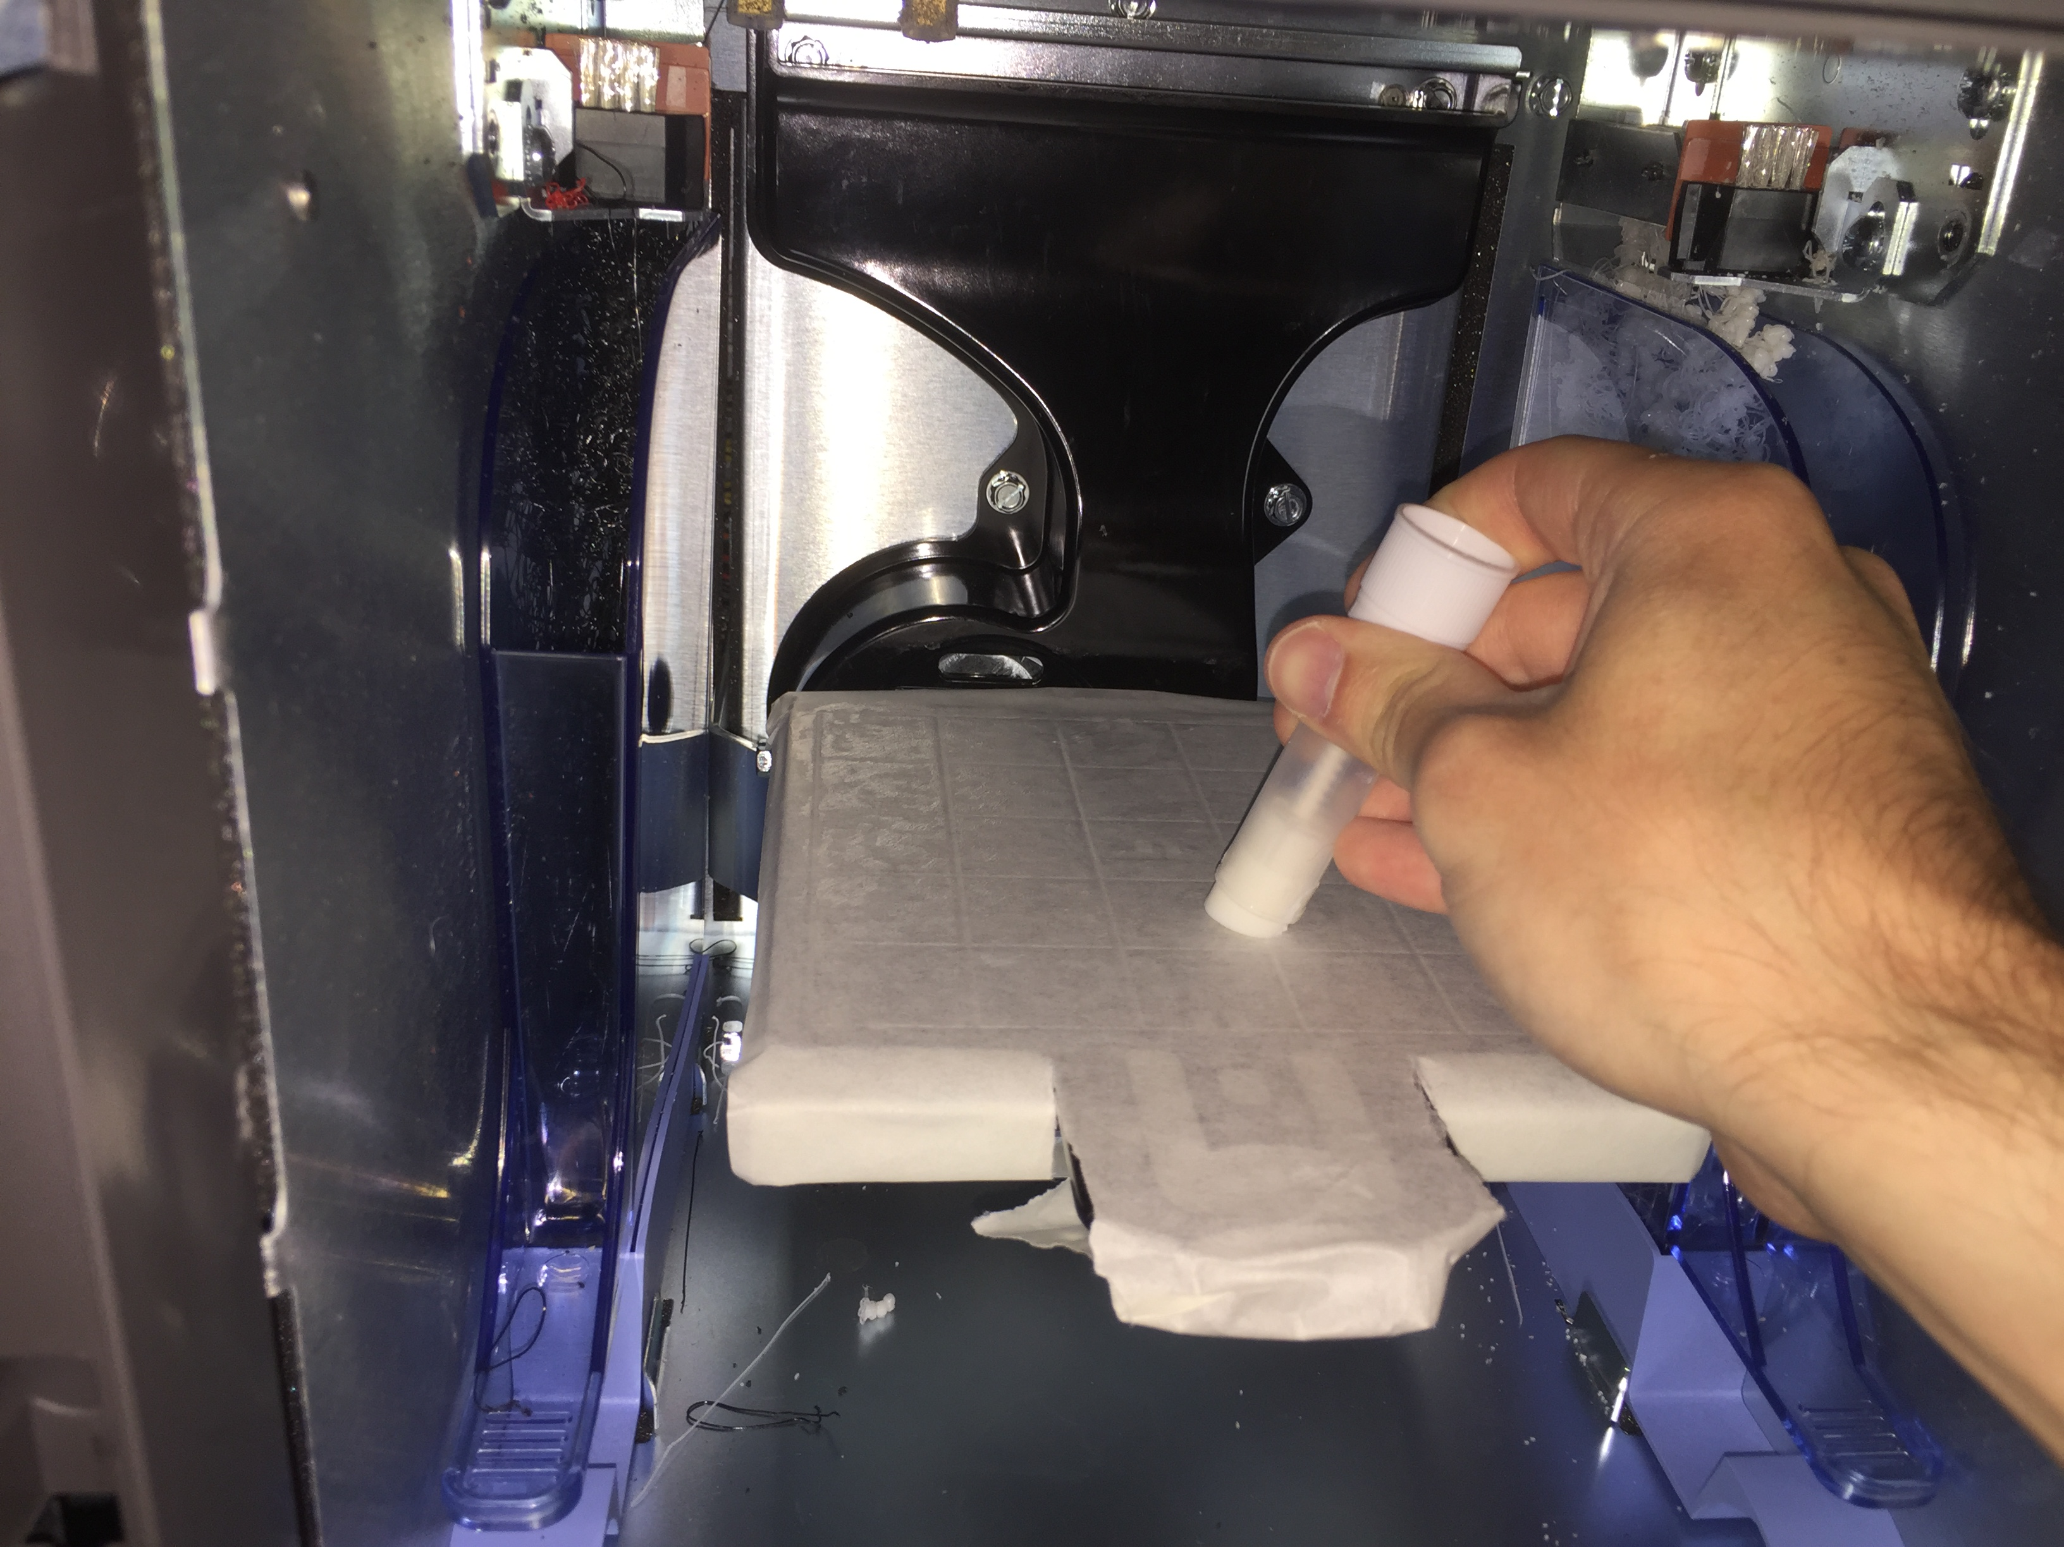
- Once again, take the squeegee and flatten the tape on the surface of the tray. If this isn’t completely flat, the printing software program will refuse to print, and you’ll be forced to restart this procedure from step 2.
- Finally take the glue stick and apply another coating to the tape-covered tray surface. This doesn’t need to be as much glue as the first step, but should still cover the surface.
With that, you’re ready to print, and the tray won’t be consumed. To clean the tray after printing, simply remove the 3D printed structure and the tape and wash the board with soap and water and scrub off the glue residue and leave it to dry.

Printer Calibration

After multiple test prints, it became very apparent that there was a difference between the dimensions of features in the printable STL file and the dimensions of the 3D printed model. This necessitated the printing of a “calibration cube” with various cut and extruded features on it. The results from the calibration will be recorded here:

All regions in the direction of printing or perpendicular between two cuts will increase in width by 0.005”. This means that between any boundaries (where the 3D printer stops adding material), if you draw a straight line in a direction parallel or perpendicular to the printer lines, the length of that line will be 0.005” more than your STL file will indicate.

This leads directly to another calibration feature: holes or cut features will have a width 0.01” smaller than your expectation. This is most likely because the material on either side of the cut has been expanded by the previously mentioned 0.005”.

How to apply this: If, for example, you wanted to print two parts which connect together via a rod and socket, the socket should be designed to be at least 0.01” larger in diameter, and the rod should be designed to be 0.005” smaller in diameter. Thus, if you want a 0.2” diameter rod and socket, the socket diameter should be 0.21” and the rod diameter should be 0.195” for them to fit together after printing.

Printer Notes

- Printed models should always be laid lengthwise on the printer tray such that the flattest portion of the model points down. Builds should never be “tall” if it can be avoided, as the piece will often deform if it is significantly taller than it is wide. To avoid this, even if it looks strange, try printing tall objects on their side.

- If the tape around the printer tray isn’t perfectly wrapped around such that there are no dangling bits, the tray will vibrate or otherwise move during printing, significantly distorting the resolution of the printed figures.

- The black plastic may have a lower resolution than the beige plastic based on our printing of the Josephson Junction Assemblies.

- Remove the waste material after each printing job.

How to Print a Part

- Save the part as an STL file in a known directory.
- Open Print Wizard on the desktop.
- It will prompt you to select an STL file. Select the one you want to print.
- A window should open showing the part you want to print in a box. On the far left is a tab based system that should show a thumbnail of your part. If you want to add another STL file to the print job, simply click the + button and select the new STL file, or alternatively just click and drag the STL file anywhere in the Print Wizard window.
- At the top of the window are the overall settings for the print job. These are fairly self explanatory, but for completeness they’ll be described here: The “Supports” setting will almost always be set to “SMART” which minimizes the required support material. For trickier builds the other two settings might be desirable, which simply increase the amount of support material used to better support the print job. For durable parts you’ll set the “Part Interior” setting to “Solid” which fills the part completely with material, while for lighter parts you might use the “Sparse - Low Density” setting which uses less material. The “Display Units” setting simply chooses the display units in the Print Wizard window from either inches or millimeters.
- When you click on a part’s thumbnail in the tab setting on left, it opens a window that lets you change the part’s orientation, scale, and number of copies. Additionally there’s a setting called “STL Units”, but the STL files are always saved in units of millimeters regardless of the units you used to construct the part, so just leave this setting as “Millimeters”. The other settings are obvious, and you’ll use them whenever you’re printing a part.
- It’s important to note here that parts should be laid down as flat as possible, and their tallest side should be laid flat against the print tray to attempt to minimize the errors when printing.
- After you’ve assembled all of your parts in the print job the way you desire, click the print button in the bottom right. This is a misleading button, as it doesn’t actually print when you click that, but will instead create a job and send it to the other application, “Mojo Control Panel”, that you will then print from.
- Once the job has been created, close Print Wizard and open the Mojo Control Panel from the desktop.
- Select your desired job from the dropdown window on the right side. It will give you a preview of the estimated print time and the estimated amount of material it will use.
- Assuming you’ve already followed the procedure to insert a properly prepared tray into the printer, hit the print button when you’re ready to begin.
- The printer will begin “preparing” your print job. This will take a varying amount of time depending on how difficult your part is, but you should wait and make sure it does this to completion, as occasionally it will give you an error that you’ll have to fix. When this happens, the green icon that is normally over the picture of the printer in the control panel will change to a red icon. Hovering over the red icon will tell you the error it’s currently experiencing. Most common will be an error saying the build tray isn’t flat, which means you made a mistake while preparing the tray, and will have to prepare it again so that it is actually flat.
- Once the progress bar starts showing that it’s on “Layer: # of #” then you’re free to leave, as the printer has begun printing your part.
- Once the printer has finished printing, remove the tray from the printer, and respond yes to the popup on the computer that asks if you’ve removed the part. Remove your part from the tray by either gently pulling it off, or if that fails use a flathead screwdriver and gently pry the part from the base.
- Once your parts have been removed from the tray you’ll have to dissolve all the support material. Bring your parts over to the Wave Wash apparatus.
- First, check if there’s something in the process of being cleaned. If there is, you can probably just toss your parts in if there’s room, though you should probably indicate somehow that you have done so. If there’s just the liquid in there, turn on the heater/agitator by pushing the button to the right of the carafe and put your parts in. Otherwise, if there’s no liquid left, heat up some water in the electric hot water heater, then dump the hot water into the carafe and put a cleaning pod in the water and turn on the heater/agitator. After the pod dissolves, put your parts in the liquid and add cold water to the carafe to completely cover your parts. Wait around eight hours or overnight to remove your parts.
- When the support material has fully dissolved, pour out the liquid and remove your parts. Rinse your parts with water, and leave them to dry on a paper towel.

Possible Experiment Ideas

It is my recommendation that the experiment be primarily focused on learning and applying SolidWorks and seeing how to use a 3D modeling software with a 3D printer. In this way, the experiment becomes more about learning a useful skill than diving in depth into a physical phenomenon. With that said, we can provide pre-built SolidWorks files and run simulation software within SolidWorks to explore physical phenomenon including flow rate analyses of wings or bullets, fluid dynamics in pipe systems, and motion/stress analyses of various structures. To this end, I’ve broken down a possible structure for the lab that could be sufficient. It consists of 3 modules, the first involves learning how to construct basic models in SolidWorks, the second involves printing a more complex student built or modified model, and the third involves running physics simulations using pre-built models.

Module 1: Designing in SolidWorks

To give students proper grounding in the software platform they will be asked to reproduce an “easy” model, an “intermediate” model, and a “difficult” model from detailed front, top, bottom, and side view schematics. We would ensure that we provide students with the necessary guidance to allow them to complete this module in a timely fashion without holding their hand in a step by step guide.

[Possible models will be inserted here with appropriate documentation later]

Module 2: Complex Student Project

As time is extremely limited, especially for experiments such as this which require a lot of time for printing and additional time for cleaning, it can only be reasonably expected that students will fully complete and print one project. While a project is printing, students can move on to module 3. Thus, in this module we might provide several different possible project ideas for students to pursue. Several project ideas follow.

Pelton Wheel

A Pelton Wheel is a design for a waterwheel that has been shown to have an extremely high efficiency when paired with a generator in a flowing water system. Its inventor remarked that its major drawback is the difficulty to construct it. However, with 3D printing it’s very easy to design and print a wheel, making this an excellent experiment to explore the benefits of 3D printing.

If students select this project, a possible outline of the tasks asked of them is outlined here:

- Design and construct a model Pelton Wheel in SolidWorks. This will most likely take between 2 and 4 hours, but may take longer depending on student’s proficiency with SolidWorks. Students should be able to explain the features of their design, including the shape of the buckets and the number of buckets.

- Print the wheel, learning the procedure for how to 3D print along the way.
- We would provide a axel-pulley-generator system as at left to which they can attach their printed wheel. Students would measure the power output of the generator system and relate that to the power input of the water flow to determine the efficiency of their hydropower generator. Perhaps additionally we might provide our own sample water wheels (Pelton or otherwise) that we printed earlier so that students can compare their model to ours.
- Additional questions we might ask to explore the physics include some of the following:
How might you modify your design to increase efficiency?
Why is the Pelton Wheel more efficient than other water wheel designs?
Does the weight of the wheel affect output? Would reducing its weight by cutting holes in the wheel be beneficial?

Gear System

For the more mathematically inclined, a system of toothed gears provides a practical demonstration of the use of gear ratios to produce controlled outputs. Since SolidWorks has a comprehensive physical motion interface in the assembly feature, students can design their own gear system and can observe how the gears interact with each other entirely within the software before ever printing them. Gears are also very simple to design in Solidworks, taking just a few minutes for each one.
If students select this project, a possible outline of the tasks asked of them is outlined here:

- Read documents explaining how gear systems work, detailing how angular velocity and tooth number of a driving gear affects the angular velocity of a driven gear of another tooth number. Using this knowledge, the student would design on paper a system of gears that accomplishes a specific goal, such as a driven gear that rotates at 1 RPM (A second hand of a clock) driving a gear system such that another gear rotates at 1/60 RPM in the same direction (A minute hand of a clock). Alternative nontraditional gear systems might be gears that rotate along inverted gears (planetary gears) or intermittent gear systems as below.

- After the student has selected a type of gear system to construct and designed it on paper, they can design it on SolidWorks. Depending on the student’s proficiency in SolidWorks and the type of gear system they chose to create, they may take between 1 and 4 hours to construct it. Students should be aware of how the 3D printer is calibrated before beginning this project, as SolidWorks has perfect resolution (so a 0.25” radius rod will perfectly fit into a 0.25” radius hole in SolidWorks, but the 3D printer actually prints circular holes with a diameter 0.01” smaller than projected and will print extruded circles with a diameter 0.005” larger than projected [See the Calibration Section in this document]. Thus currently a hole should be made at least 0.015” larger than desired to fit without drilling.)

- Before attempting to print their individual gears, students should assemble their entire system in SolidWorks and use the motor function on the driving gear in the Motion Study section of SolidWorks to demonstrate that their system behaves as expected. Once this has been confirmed, then they can print their system.

- We should provide a motor and an axel on which the student can mount their system and test that it works as expected. Depending on the type of gear system the student constructed, they will measure the quantities they projected in the initial design stage. As this experiment is largely dependent on the initial design stage, the measurements here are limited in scope.
- Additional questions we might ask (regardless of the student’s chosen gear system include the following:
What are some applications of intermittent gear systems?
How does modeling a mechanical system in a 3D software platform aid its real life construction?
While very good, SolidWorks sometimes shows a mechanical system working perfectly while in reality it wouldn’t work. Based on what you’ve seen, where might these errors come from?
- Resources: https://newgottland.com/2012/01/08/make-geneva-wheels-of-any-size/

Module 3: SolidWorks Simulations

Solidworks has comprehensive simulations software that allows students to explore various forms of physics on 3D models entirely within the software. Students may conduct flow analyses to explore fluid dynamics, motion analyses to explore classical mechanics, thermal analyses to explore thermodynamics, and stress tests to explore structural mechanics. In this module, we would provide the SolidWorks files that students could run simulations on and record their results. This provides the actual physics in this experiment, while further developing students’ abilities in the SolidWorks platform. There are many possibilities here, and a whole host of sample simulations can be downloaded from SolidWorks or elsewhere. The following are possible ideas for the SolidWorks simulations based on the curriculum of the 5 series.

Glider in a Simulated Wind Tunnel

Using the Flow Simulation feature on SolidWorks, students can view an intuitive system for how air (or any other fluid) passes around the glider and may view contour maps of where the model experiences forces. Students may be asked to make simple changes to the glider such as adding a large non-aerodynamic feature and then resume the flow simulation to examine how the flow simulation changed.

Bullet in a Simulated Pool

Still using the Flow Simulation tool, students can evaluate the force required for a bullet to reach a certain velocity in water (or any other fluid) or reversely, use a known force of a bullet firing to compute how it would behave in the fluid.

Firing a Trebuchet

On their website, SolidWorks has a list of educational resources that may be freely accessed to teach students about SolidWorks. In that list is a complete motion study of a trebuchet launching a projectile at an obstacle. Students can completely evaluate this motion, running Newtonian calculations on the trajectory and using that to determine launch velocity. Students can also study the mechanism of the trebuchet itself, examining how the drop of the counterweight causes a force sufficient to launch the projectile hundreds of virtual meters.

Heating a Static Electronic Circuit

When circuits are constructed, its capacity to withstand heat must be evaluated in order to avoid failure. In SolidWorks Thermal Simulation, students can observe the effects of heating up an electronic circuit, noting its expansion and its material dependent deformation. Students can measure the heat dissipation over time after a heat source is removed (the circuit turns off), and generate an animation showing the temperature flow of the circuit. Students may increase the heat flow into the circuit until they achieve a critical failure of the circuit, and measure the maximum allowed temperature and plot the strain on the circuit with heat.

Flow Through Pipe System

Using the Flow Simulation tool, students can examine fluids as they pass through a system of pipes. This will allow a direct application of Bernoulli physics in action as students can observe how fluids behave as they pass through different size pipes and how they’ll behave as they move lower in the pipe system. Additionally, students might care to see how the pipe system handles the fluid pressure, and can observe where pipes are likely to break and would require reinforcement.

Resources

SolidWorks Tutorials

Basic SolidWorks Tools Tutorial:
https://www.youtube.com/watch?v=cy3ExIAcI2Y (Part 1)
https://www.youtube.com/watch?v=ll_9D6J2yT0 (Part 2)
https://www.youtube.com/watch?v=ofYL-lCrEv4 (Part 3)

Basic Part Construction:
https://www.youtube.com/watch?v=TvBoZ6kH3Q8

Complete Basic Build Tutorial:
https://www.youtube.com/watch?v=9f2huG_qQaE&t=3715s

Basic Gear Tutorial:
https://www.youtube.com/watch?v=Q7-dOJoKs90

Flow Simulation Tutorials:
https://www.youtube.com/watch?v=tMA3t9MrsGs (Pipes)
https://www.youtube.com/watch?v=8dB3rHustnY (Glider)

Thermal Simulation Tutorial:
https://www.youtube.com/watch?v=9V8bLTnGZ84

